Student’s name | …………………………………………………….…… | Grade | 3
Subject | Computer | Week No. | 12
Lesson Title | Conditions | Unit
Worksheet No. ( 12 ) (Answer)

Question A: Write the correct name of each part.

Set style | If-Then | Forever | Go To x-y

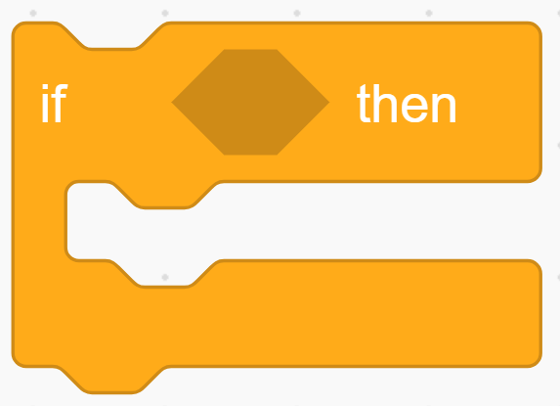
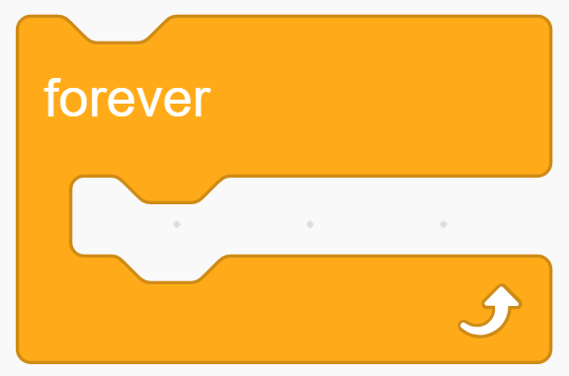

If-Then
Go To x-y
Forever
Set style
Good Luck

